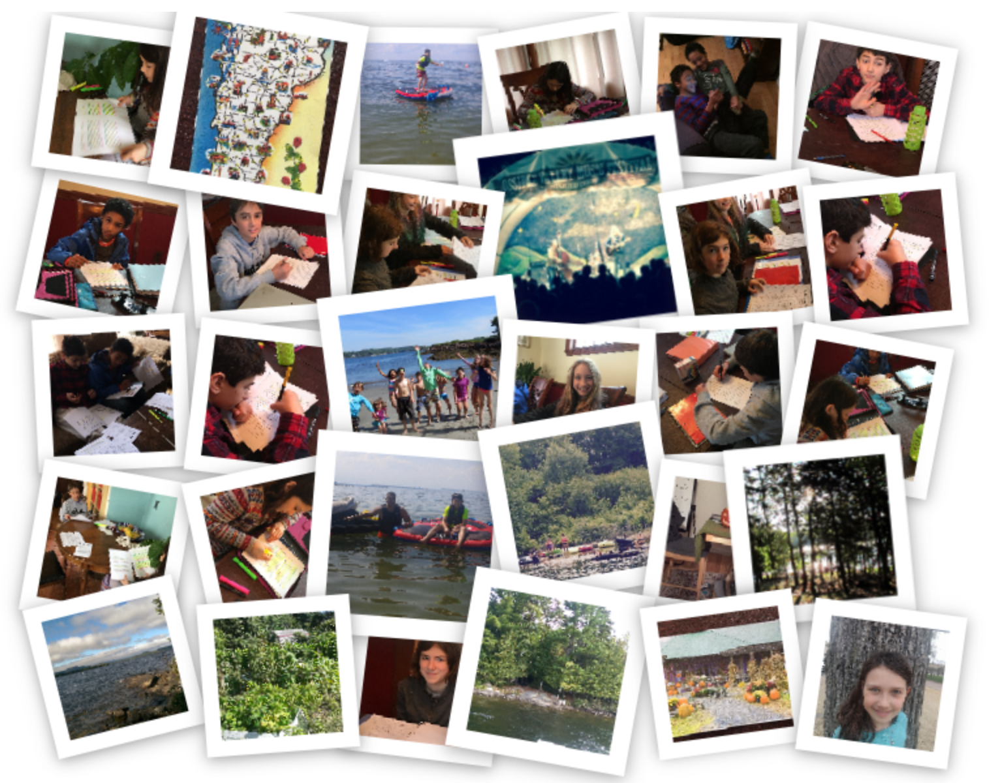
West Ossipee Home at the Hermit Valley Music Festival on Umbagog Island in Isplip, Vermont – March 2017

Collected Essays: Places
Home Scholars of Boston
Instructor Linda Carney-Goodrich

Students

Collected Essays: Places
Phaidon Athanasopoulos – West Islip 4
Sofia Grabiel Butler - Umbagog 6
Michaela Edwards - Ossipee Valley Music Festival 8
Aydin Hodjat - My Favorite Place to Be 10
Romeo Pelletier – Hermit Island 12
Colette Stamatos – Vermont 14

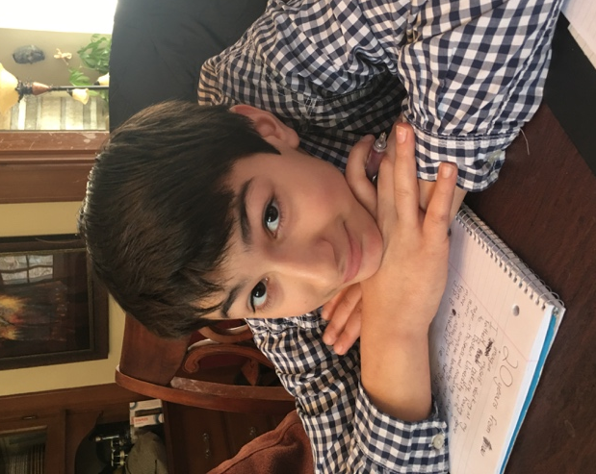
Phaidon Athanasopoulos – West Islip

West Islip
My favorite place to be is the little town of West Islip, Long Island, New York. Long Island lies west of NYC, jutting into the Atlantic Ocean. My grandparents have lived there for over fifty years after immigrating from Greece. My family has some relatives there, including my mom’s brother and his family, as well as her cousin. We have friends there, too. I like staying at my mom’s old house with my grandmother’s vast backyard and garden and my grandfather’s machinist workshop. Let’s not forget the great beaches surrounding it. West Islip is a great town to spend time in.
Firstly, the beach. Long Island beaches are phenomenal. The water there is surprisingly warm due to the gulf stream. The beaches on the ocean side have huge waves that tower over me; it’s a lot of fun jumping on or through them, or letting them crash on you. Some beaches are not too deep, especially on the bay side, and are great for swimming. I used to dislike swimming in deep water, because I was afraid of the crabs that could be on the seafloor, but my parents would tell me multiple times that the crabs are more afraid of me than I am of them. Sometimes, when it’s really windy and you try to swim, the current can take you a good ten feet without realizing it! I also love to fish on the beaches. Sometimes I fish with my mom’s cousin, Nick, who’s a policeman. Nick and I sometimes go fishing out on the Atlantic with his police friends on his boat. I once caught a shark, and I earned my nickname: shark boy. When I fish from the shore with a rod, I usually catch snappers, a type of small, silver fish. We also go seine fishing with a large net that my grandparents brought from Greece. The beaches there are great.
My second reason to love Long Island is of all of our friends and family. My mom’s cousin and his new fiancé live in an adjacent town of West Islip, named Bay Shore. They come and visit us a lot. Sometimes my sisters and I wrestle Nick. When his fiancé, Billie, comes, she pulls up in her BMW convertible, and sometimes give us toys, like old water guns that her kids grew out of. Every summer, they invite us to go jet skiing and tubing with them. Tubing is riding on a large, thick, soft and floating platform that Nick and I hold onto while Billie and my sisters drag us behind the jet ski! I once fell off, and the water nearly ripped my swimsuit off. My cousins live farther north and east than West Islip, but we still see each other. They live really close to the beach and my cousin Harry, who is now 14, and I enjoy going kayaking. One time, when we had the kayak, Harry’s sisters and my sisters played a game where we tried to get on and off so that the whole thing just kept toppling over! My family also has friends that come from NYC every week to go to a beach that is really close to us called Captree. We can spend all day at Captree, fishing, making and destroying sand structures, and swimming for as long we like. My friends and family are the best. 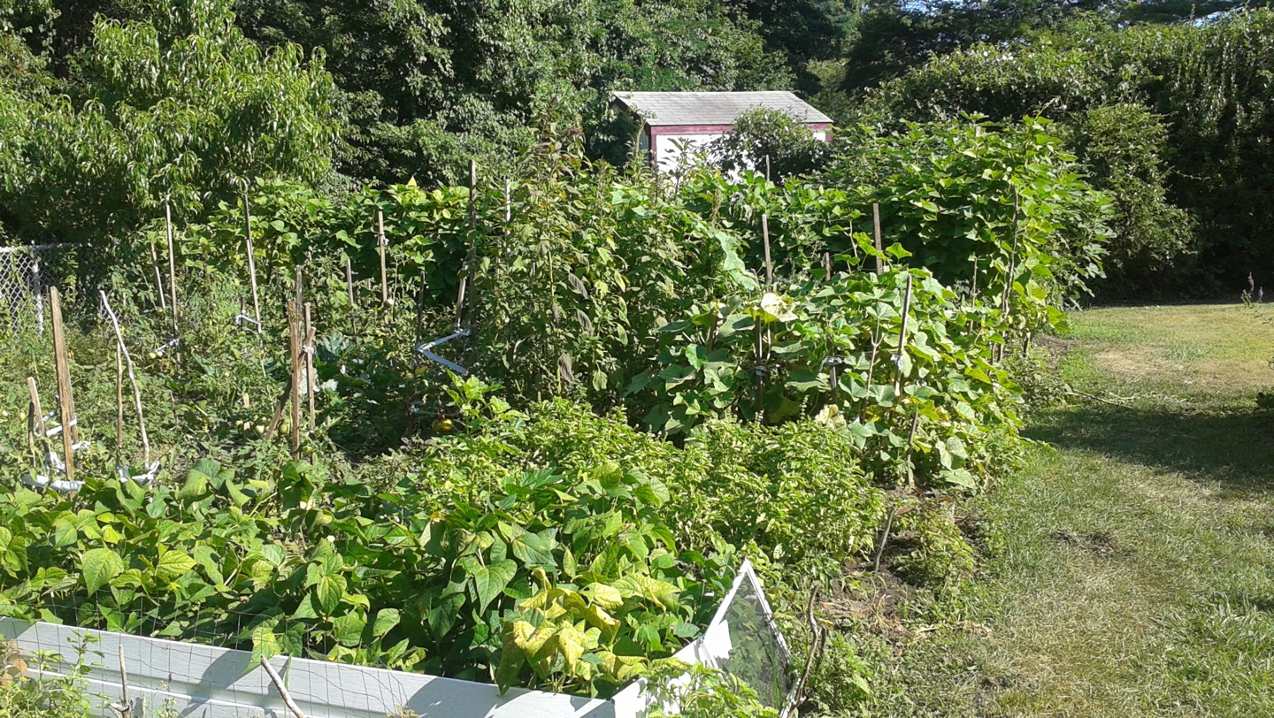
My final reason is the town of West Islip. My mom grew up there as a kid. She sometimes shows me her old schools, and when we pass her old friends’ houses, she amazingly remembers their entire names, last names and all. I remember a time when we passed her old middle school, and she told me they were the most miserable years of her life, but we also pass her high school sometimes and she was valedictorian there! On the weekends in West Islip, the town is flooded with garage sales, and I love going to garage sales. One time, I found two lego sets! My grandmother’s house is fun to visit. This is no normal house; it is literally a time machine that travels from the twentieth century to the sixties. From the wood paneled walls to the ancient kitchen, it’s like you’re in the “Brady Bunch”! I like searching in my grandmother’s attic or my grandfather’s workshop. His shop is one of the most interesting places ever. Everything surprisingly still works, even though all of it is from the sixties. He has a massive lathe, which is a machine used for shaping wood, metal, and other materials. He also has two drill presses, a belt sander, which is basically a big strip of sandpaper on a spinning wheel, and an unbelievable number of tools. My grandmother’s attic is also very interesting. I once found a sixties movie camera, the ones that look like guns, a four million pound projector, and speakers for the projector! The back yard is also tremendous. My grandmother has a garden the size of one-fourth of a one hundred yard football field! She grows tomatoes, cucumbers, potatoes, etcetera. I like to wake up and go outside to harvest green beans with her. I really love West Islip.
West Islip is a great town for all of those many reasons and more. It’s where we spend nearly every summer, where we have dinner with friends and family, where we swim in the warm water, where I think about what it would be like to grow up there during my mother’s childhood. I love West Islip, and I know it’s just a location for other people, but I don’t know what I would do without it.

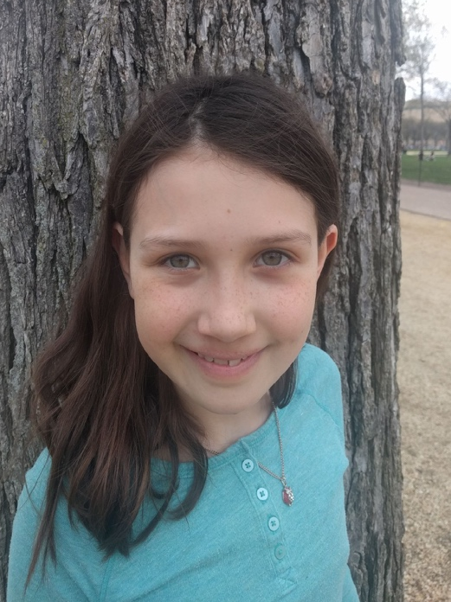
Sofia Grabiel Butler - Umbagog

Umbagog

Umbagog Lake is as close to a paradise as I have gotten. Umbagog State Park is on the New Hampshire - Maine border, far from the hustle and bustle of the city. In order to camp on one of Umbagog’s many remote campsites, the park rangers take us and our equipment on a motorboat eight miles onto the lake. They unload us on a campsite we’ve reserved, and we do not see them again until the end of our trip. Umbagog is fun, peaceful, and beautiful. It is one of my favorite places.
To start with, I like Umbagog because I can do a lot of my favorite things there. Swimming in the crisp, clear water can really cool me off on a hot day. Nighttime or sunset swims are really fun too. I can go canoeing or kayaking to the islands. We usually rent canoes for trips around the islands. I also like to explore on our peninsula and the islands by walking through or around them. They feel like islands, but most of them are part of the mainland. Sometimes I get a little bit wet, but it is still fun.
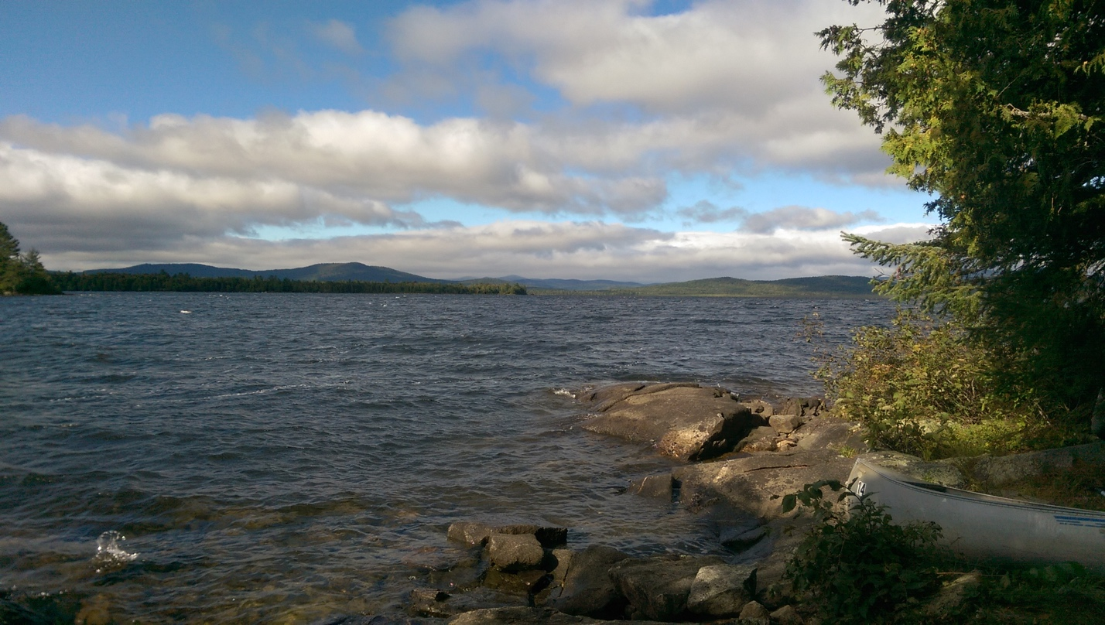
Furthermore, Umbagog is one of my favorite places because it is so peaceful. I can’t hear any cars because there are no roads nearby. The waves don’t crash on the rocks like they do at the ocean because it is a lake. There are no other people near our campsite, only animals like raccoons, nuthatches, and deer, so it is quiet in the day. It makes me feel quiet too.
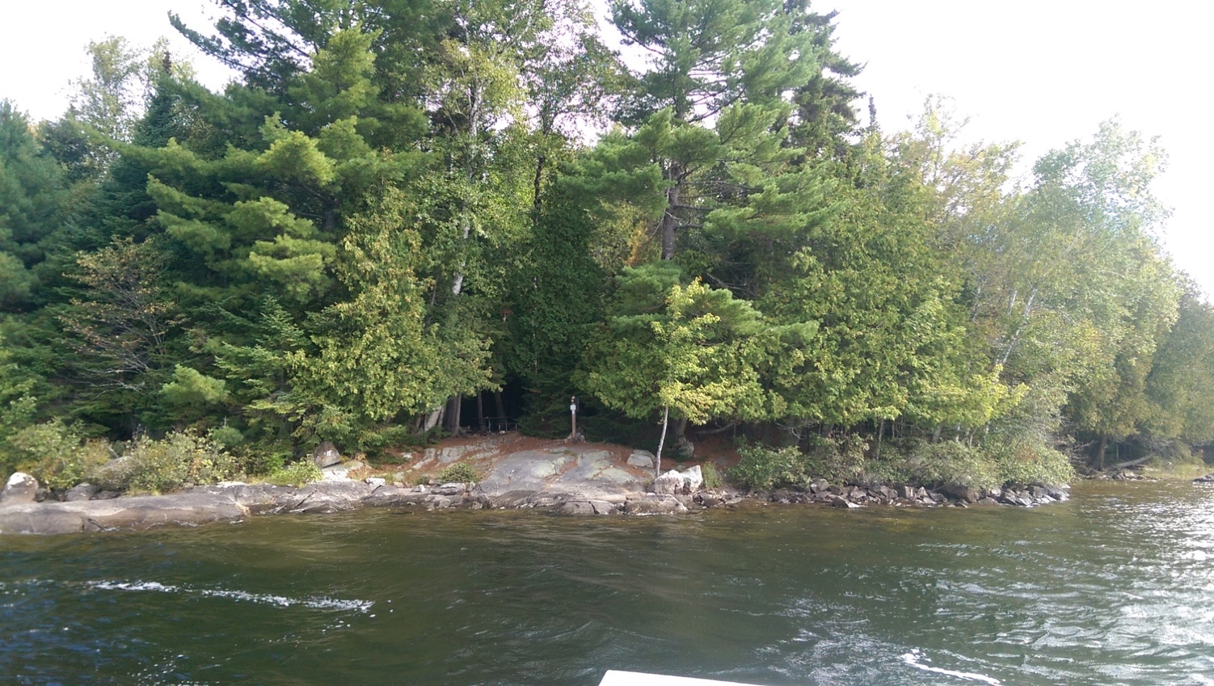
Lastly, Umbagog is one of my favorite places because of the spectacular view. I can see all the trees on the islands and peninsulas that I know are so large, only they seem so small. It makes me realize how huge the lake is. I can’t even see the end. There are no buildings in sight, the only things I can see are water, land, and sky. Sometimes, if I’m lucky, I can see and hear loons on the water. If I’m very lucky, I can see their necklaces and their spots. The view is so beautiful and I don’t think I could take everything, even if I could see it all.

One of my favorite memories of Umbagog was during the morning of our last day there. We woke up really early and got out of our tent. Not wanting to disturb the quiet, we slowly got in our canoe and paddled out on the still water. As we moved away from the peninsula, we heard a loon. It was a very still moment, the sun rising in front of us, the other islands becoming visible in the morning light, and a flock of geese flying across the lake. We stopped the canoe and admired the view. We were surrounded by islands, and they stretched as far as I could see. I’ve saved this view as my favorite memory at Umbagog Lake State Park in New Hampshire. Everything is always so peaceful when I’m there, there is always a beautiful view, and there's always something fun to do.

Michaela Edwards - Ossipee Valley Music Festival

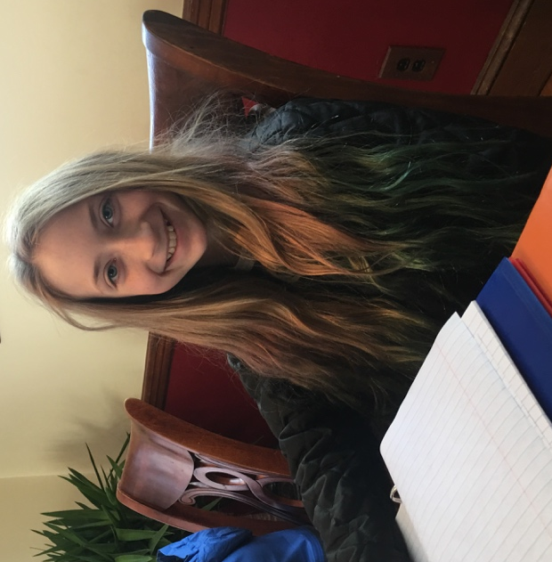
My Favorite Place to Go

Every summer, my parents, our family friends and I all go to a place that I couldn’t describe as anything but perfect. It’s called Ossipee Valley Music Festival, and it’s in Maine. The first time we went was when I was 1 year old and we have been going every year since then. It consists of four days of camping, with best friends. There is a constant supply of amazing music. It is, plain and simple, the most fun one could ever have. This festival is definitely my favorite place to go!
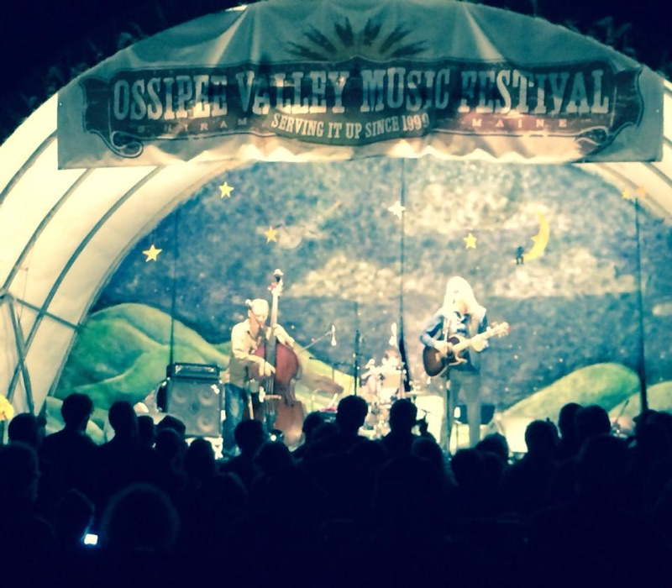
The first reason that I love the festival is the swimming. One of the places I love to swim is a long dark river that’s only a five-minute hike through the woods from camp. Sometimes, we try to swim to the other side right through the stream of water, when it’s really strong. There are slimy rocks on the bottom and lots of tangled up seaweed. Off to the side of the main river area, there’s an old red rope swing that someone tied up years ago. To get onto it we have to climb up a flat wall of dirt, holding onto small plants, hoping they won’t break. We take turns pushing each other up the small edge with all of our strength. Then we’ll go swinging around and flying into the cold water, splashing everyone in sight. Another place that we go swimming is somewhere that we found only two years ago. It’s a small lake that has a little beach on it. About fifty meters out, someone dumped a whole bunch of white sand. Now it’s the perfect place. There’s no seaweed or slimy rocks, just nice sand, and the water is always comfortably warm, yet still refreshing. The water is incredibly clear, and it all just seems out of a movie. I also love that sometimes we bring inflatable loungers for the water. All the kids stuff onto them and we play the speckled frog game. In the game, we sing the speckled frog song then fight to stay on the raft and try to push other people off. This goes on until there is one winner. We all try to do cartwheels and handstands on the raft, and back and front flips off of it. I really love all of the swimming there because it is just what you need in the hot summer.
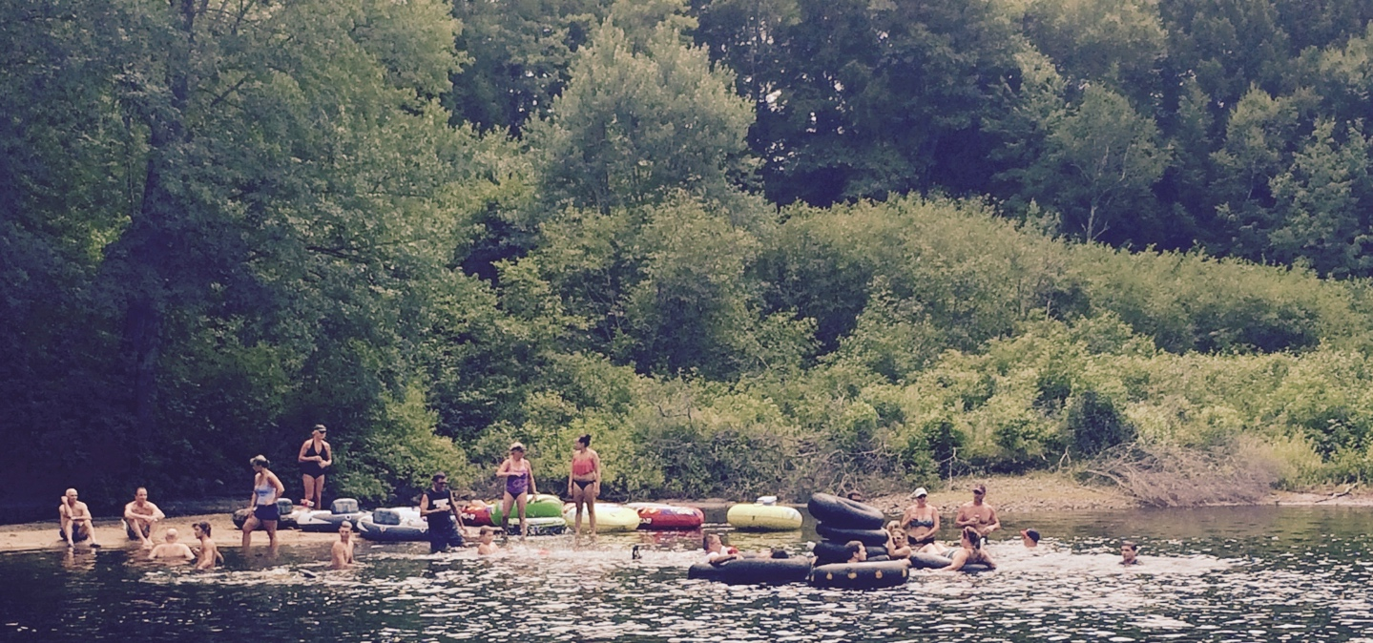
Another reason I love the festival is the setting. First of all, it seems as if we are in our own little town. There are all sorts of pop up stands on the sides of a small dirt road, where cars can’t drive. The stands are full of goods ranging from ice cream to amazing handmade jewelry. As far as food goes there are varieties from BBQ to Thai. My favorite things to get are gator balls (meatballs wrapped in bacon with BBQ sauce). One cool part of it is that the kids can just roam free. Usually we have bikes so we can travel quickly. We have all been going for over 8 years, so at this point we get around without thinking. We stroll about as if it is our second home. My favorite place to go is old barns, that has wooden bleachers in it and cement floors. It has a small stage in the corner where smaller bands perform and teach music workshops. One of the best parts of the festival is everyone acts as if, in the four days camping, we are all one big family. Generally, the same people go every year, give or take a few. So everyone is super friendly and happy around others even if they never met the person. For example, I’ve had people come up to me and say they remembered me from years ago. Someone may also find a person they played with as a toddler, and get along just the same. I love that it is a very welcoming, neat environment to everyone participating.
Finally, the obvious reason that I like the festival is the music and dance! One of my absolute favorite parts is the barn dance. Every night a band comes up on the little stage in the barn. They play all sorts of crazy upbeat songs. It starts at nine o‘clock and goes to eleven o’clock. Everybody goes absolutely crazy with their dancing. It is so insanely fun, and afterwards, it’s just the best feeling ever to walk back to our tents exhausted from having some of the most fun of our lives. Another main part of the music is the main stage. The biggest performance is at night. You bring folding chairs and leave them out in front of the stage for the whole time you are there. Whenever you want you can go and listen to music. Usually, we bring blankets and cuddle up under the stars listening to some amazing music. Sometimes the best part is looking out into the crowd of hundreds of people, and the people dancing in the grass behind you. Another awesome part is that, even if you aren’t at a stage, you hear music. All day every day, whether it’s the main stage or someone’s tent, you hear music. It’s amazing how cool all the music is. One of my favorite feelings is laying down in your tent at night, and hearing the music from the various camps and small stages. It’s the perfect thing to fall asleep to. I think that all the different music, songs, and voices are a big part of the reason that the festival is so great.
For all of these reasons, this music festival is the kind of place that I look forward to year round. My friends and I start thinking about the festival a week after we leave. I honestly wish that I could be there right now, flipping on the rafts with my friends and dancing in the barn like crazy. I love everything about the festival, and am longing to be there soon. It is definitely my favorite place to go. I can’t wait to go back this summer!

Aydin Hodjat - My Favorite Place to Be

My Favorite Place to Be
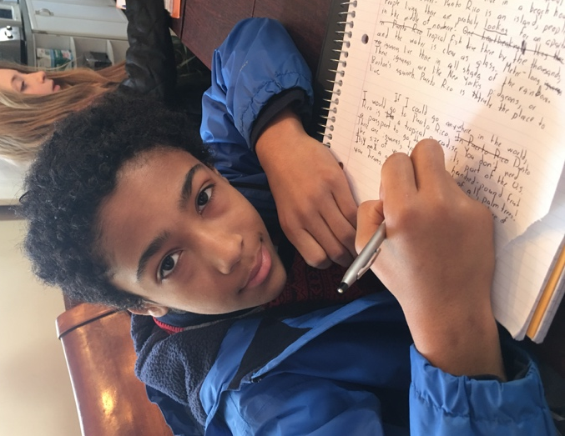
Some people love to visit faraway locales by taking luxury cruises. Some delight in lying on a towel, wearing a swimsuit, and soaking in the hot sun at the beach. Countless others like hiking deep into the wilderness and sleeping under the night sky. For many people, an exotic or out-of-the-ordinary location is the place that they treasure and love. I, however, prefer a warm and comfortable place where I can enjoy all my favorite activities for free. A place where you don’t have to worry about the room service bill. A place where you can enjoy the necessities of life, like Wi-Fi and free TV. Even though there is no pool, my favorite place is home.
Why, you might ask, would home be my favorite place? The answer is in all of the luxurious things I can delight in that are right in my house. Camping can be fun, but when camping, one has to either ration food and water, or bring a lot of it, which can be a hassle. At home, there is no need for me to do any of that. Hotels can be great to stay in, but how can I really feel any privacy knowing that half the employees have keys to my room? At home, the only keys to my house are with my family. Going to the beach can be exciting, but getting sand in my suit can feel like the end of the world. Besides, the ocean water is always cold in New England. Who needs the beach when I can lie in my warm tub at home for as long as I feel like it?
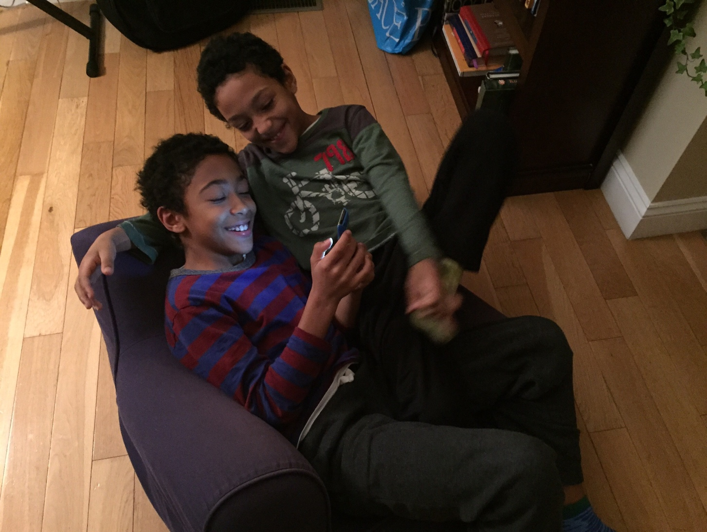
Even if I were to omit the luxurious things about my house, there would still be many bonuses to the place I call home. My house is where I feel the safest. I trust my house with protecting my family from the dangerous world outside. These everyday fortresses are designed to keep out anything from greedy robbers to howling storms. My home is like a best friend. It is always there in times of need. Within its safe walls, I feel like a king majestically ruling over my realm. It sounds almost preposterous to think of anybody daring to “attack” my “realm”, and woe unto those who would dare.
One final reason why I love my home is my family. I can always be sure that they will be at home with me ready to have a good time. With my family I can play games and tell jokes. Sure, I can do the same things with other friends, but with my family, I generally feel more comfortable. Besides, my other friends cannot live with me. My family has tailored my home to suit me as much as possible. They surround me with items, toys and gimmicks, and are happy to use them with me. My family provides the ultimate playmates.
Home is a vault of the richest possible activities. I can lie out on the couch for hours, listening to music and drinking soda. I can break out a book and immerse myself in fantastical and mysterious multiverses. Home is tailored to reflect me, who I am, and what I love most. It is impossible for me to not consider my home the place I enjoy most. It is the one true place where I can really feel, well, at home.

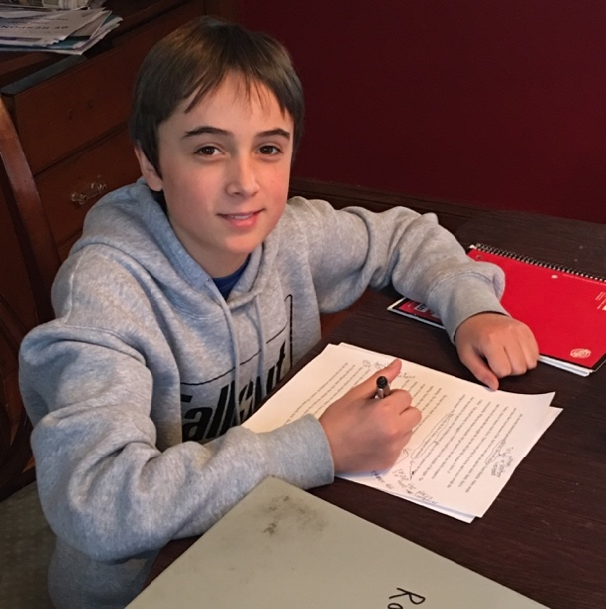
Romeo Pelletier – Hermit Island

Hermit Island

My favorite place to visit is Hermit Island. Hermit Island technically isn’t an island, since it’s connected to the mainland by a small land bridge. Cars use this land bridge to cross over to the “island.” Hermit Island is located in the small town of Phippsburg, Maine. Phippsburg is directly outside of Bath, the state’s largest boat manufacturer. Hermit Island is a two-and-a-half-hour car drive from my house in Boston. That means lots of cramps when we finally get out of the car.
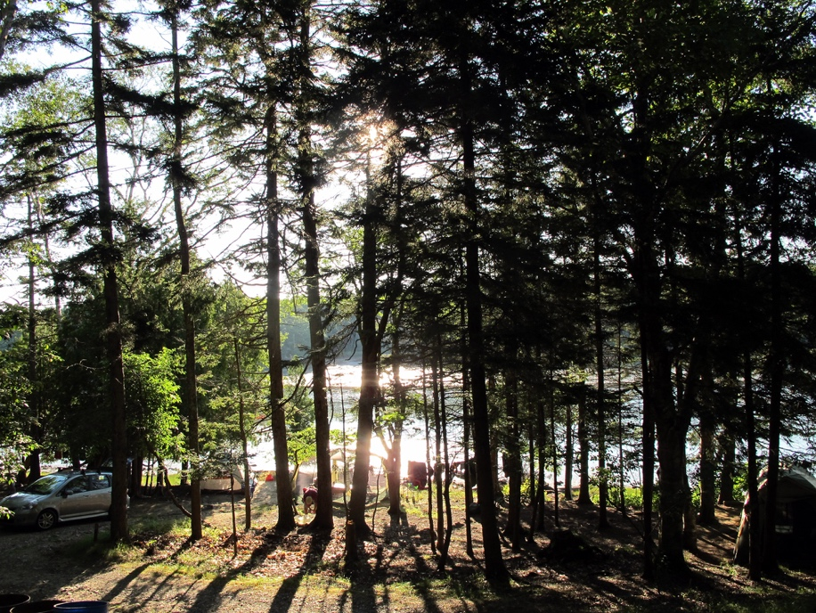
I always feel a rush of excitement when we start driving down Branch. That’s wthe road that my entire family camps at for one week every August. Since it’s summer, we can swim, hike and run around in the woods all day and night. Branch really is a great place to camp. It’s right by the water, it has plenty of strangely shaped climbing trees and, in my opinion, it has some of the best sites on the island. Also, it leads straight to the red dock. We kids of the family spend most of our time on that dock talking, putting on little skits and goofing around. Branch is definitely one of the most exciting places to camp on Hermit Island.
Another thing that I like about the annual Hermit Island trip is being with my extended family for an entire week. All the cousins are very close in age, the eleven kids ranging from seven to twelve years old. That’s plenty of kids for our nightly woodland Manhunt games. There are seven cousins, two families of second cousins, two kids each, four uncles, four aunts and one pair of grandparents-- all from my dad’s side—who come to Hermit Island. I also like going to the beach every day with my family. I can always be sure that I’ll get plenty of swimming in during that week. Being with my family while camping really makes everything ten times better.
Yet another thing that I enjoy at Hermit Island is constantly being out in nature. We always see lots of wildlife there. Some wildlife that we see include deer, osprey, eagles, seals, lobsters, crabs. Also, it’s nice and quiet out there. There aren’t any roaring trucks or screeching cars. One last great thing about being out in nature is that it’s so fun to explore. We kids can always find new oceanside caves or groves of trees to check out. Along with everything else, being out in nature really makes every Hermit Island trip quite an experience.
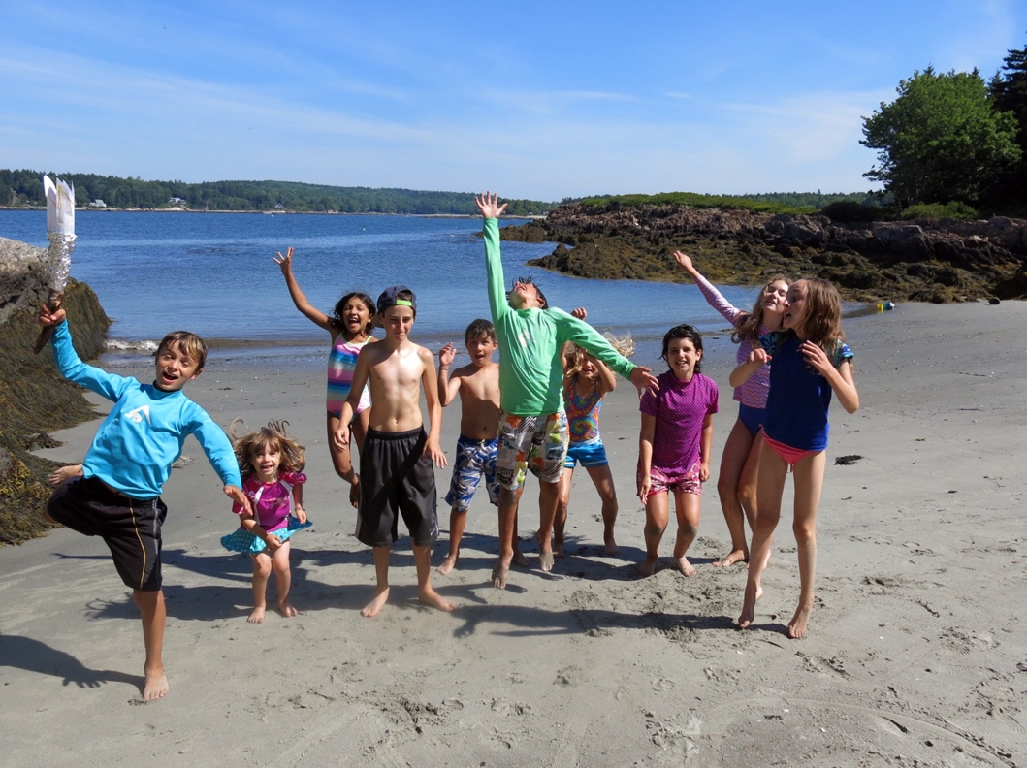
Hermit Island has been my favorite place to go ever since my first time there when I was three. The tradition didn’t start there, though; my dad and his brothers have been coming to Hermit Island ever since they were very little as well. For me, the best thing about Hermit Island is the pure adventure in everything. There’s always something new to do there. I always relish that week of excitement and high adventure, although it does always go by too fast. Hermit Island is my favorite place to be and I hope that I can continue to go there with my family for the rest of my life.

Colette Stamatos – Vermont

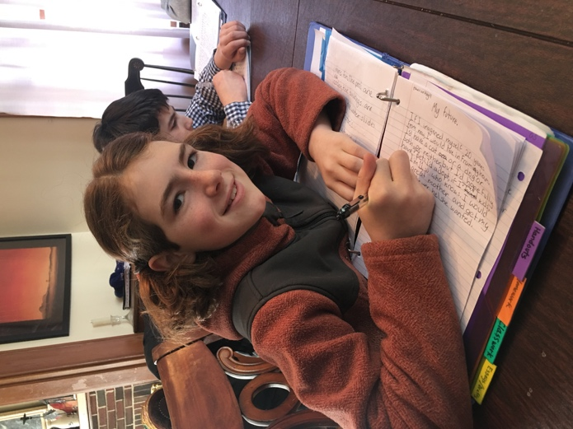
Vermont

My favorite place is Vermont for many reasons. First, I really appreciate the trees there, and the animals in them. The trees in my opinion, are good and fun to play on, to play near, and they help the farmers in the area with their jobs, by providing sap for syrup. Also, at least when it's summer, and if my brother is even around at the time, we used to climb the tallest trees to prove who could go higher, or who can jump off the highest branch. It was quite amusing, most of the time. When my family and I go to Vermont when it's a colder season, the trees are covered in a beautiful layer of white powder, otherwise known as snow. Nobody does really anything with the trees, they are only for admiring when it comes to below freezing temperatures. I still love Vermont.
Vermont is also my favorite place for the farms or just the country in general. My friends’ parents own a farm located in the town of Hardwick. They have at least 11 pets, not counting the chickens. I love all the animals on farms, the cows always grazing in the field while the pigs fight for the last morsels of slimy compost, the smell attracting all the flies from here to China, and the chickens pecking at the ground, looking for their own dinner. I also love the fresh food when I go to a farm. It's always tasty to have freshly squeezed apple cider on a cold fall day. Farms are awesome.
Third of all, I like Vermont for my friends and family. I don't have actual relatives living in Vermont, but I do have the one friend who lives on the farm. We don't see each other much, but we are pen pals, so we write. I like Vermont for my family because even if I see them at my house, I spend more time with them in Vermont. The reason, I know, is probably because there are no jobs to run off to when one is 3 hours away from home. Still, it's always fun to spend time with them.
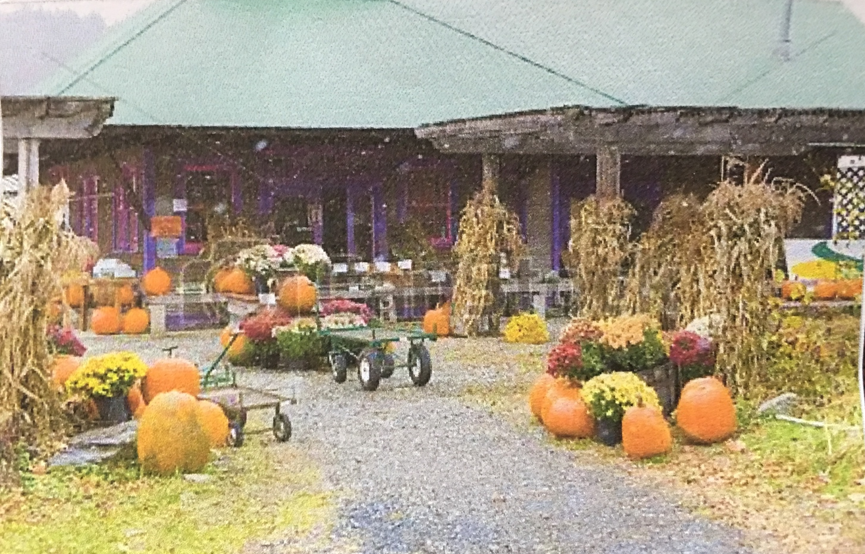
Sometimes I go skiing on the mountains with my Mom and brothers in Vermont. I love to ski really fast, usually ready to go flying, land on my face, and end the trip, but I enjoy it while it lasts. I love the food at the resort, the burgers are giant!!! My brother pigs out on the fries, my Mom has salad, my other brother has salad too, and I eat a burger. ALWAYS. Most and last of all I like to spend time with my family. It's fun, even if my brothers complain and my Dad is just sitting there. I love skiing!
I really like hiking in Vermont. I go hiking with my family. It takes a long time, but it's worth it when I get to the top and see the whole town. I love Vermont for a lot of reasons, and what I've said so far is only a few of them. I love Vermont for skiing, hiking, friends, and farms. If I want more I would probably have more reasons to go again, and so would my family. Vermont is my favorite place.

