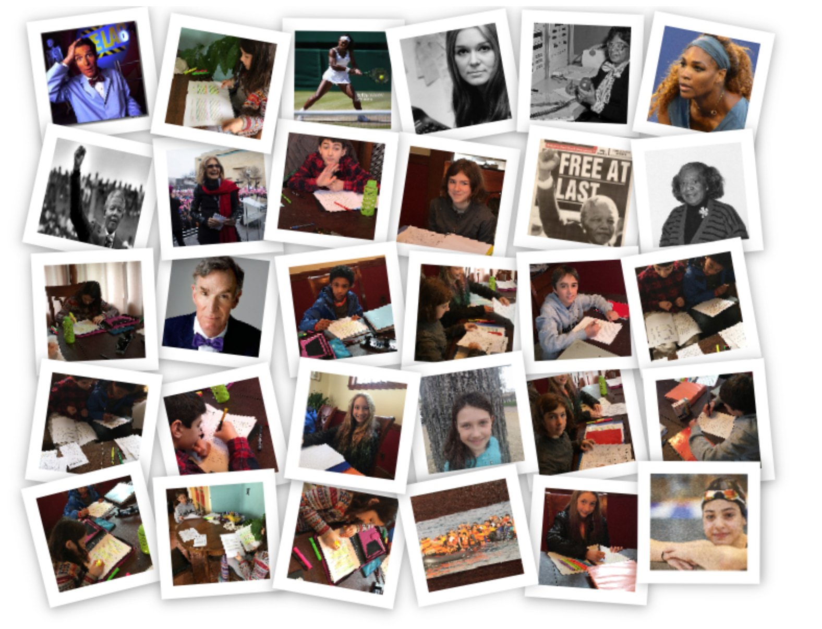
Essays – March 2017

Collected Essays: People

Home Scholars of Boston
Instructor Linda Carney-Goodrich

Students

Collected Essays: People
Phaidon Athanasopoulos – Nelson Mandela 3
Sofia Grabiel Butler – Gloria Steinem 6
Michaela Edwards – Mary Jackson 8
Aydin Hodjat – Serena Williams 10
Romeo Pelletier – Bill Nye 12
Colette Stamatos – Yusra Mardini 14

Phaidon Athanasopoulos – Nelson Mandela
Home Scholars of Boston
Instructor Linda Carney-Goodrich
www.homescholarsofboston.com
linda@homescholarsofboston.com

Nelson Mandela
Nelson Mandela was and is an inspirational figure known throughout the world. He fought against white supremacy in his country, South Africa. He was put in jail for nearly three decades for his anti-government activities. He was the first African democratically elected president of South Africa. Despite his harsh experience, his forgiving and unselfish soul inspires many people, including me.

Rolihlahla Mandela was born on July 18, 1918. His family descended from royalty and his father was chief of his town. He later went to school where he picked up his nickname, Nelson, from a teacher. He then attended the University of Witwatersrand, where he got degree in law, and met activists against Apartheid, a system established in 1948 that legally enforced segregation. The system was not fair to black people. They had to live in certain places, the could not vote, travel freely, or marry a white person. The schools and public places were also segregated. Mandela decided that Apartheid must end.
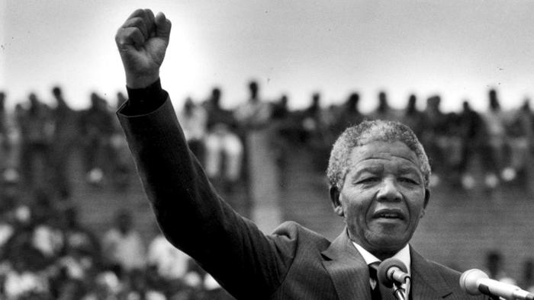
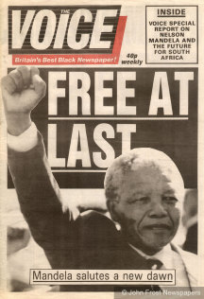
He traveled throughout South Africa encouraging people to participate in nonviolent protests against Apartheid. Mandela joined the ANC (African National Congress), a political group aiming for a democratic government, became one of its leaders, and helped establish the ANCYL (African National Congress Youth League), a youth wing of the ANC. He was arrested and sentenced to life in prison for organizing anti-government activities. At his trial, he said “I have cherished the ideal of a democratic and free society in which all persons live together in harmony and with equal opportunities. It is an ideal which I hope to live for and to achieve, but if need be it is an ideal for which I am prepared to die.” That is one of my favorite quotes from him. Mandela spent twenty-seven years in prison, but even behind bars, he still united people, and that inspires me. Even though he was in jail, he still moved people.

In February 1990, he was released by F. W. de Klerk, the leader of South Africa at the time. He and de Klerk worked together to end Apartheid, and in 1994, Mandela was elected as the first black president of South Africa. He stepped down as president in 1999. He was honored with many peace awards, including the Nobel Peace Prize. Mandela died on Dec. 5, 2013. He was 95. He continues to inspire people today.
“It is an ideal which I hope to live for and to achieve, but if need be it is an ideal for which I am prepared to die.”

Mandela inspired me because he worked extremely hard for a goal and persevered. He struggled against a whole country's government for equality and freedom. Even now that he is dead, he still inspires many people to work hard to improve the world. His goal to end Apartheid seemed impossible, but he accomplished it. His example inspires me to work hard toward a goal despite obstacles in my way. Even when he failed, he never gave up. I would like to be like him and be strong enough to keep trying even when the odds are against me.

Sofia Grabiel Butler – Gloria Steinem

Gloria Steinem
I look up to someone who has made it easier for young women to grow up and move on through life. Someone who, as a child, had to do a lot of things by herself that I hopefully won’t have to do alone. I look up to someone who had a hard time finding a job that was important and would do more than just pay her less than a man for her work. I look up to a feminist who started her own organizations and magazine just for women who want to fight sexual discrimination: a courageous woman whose name is Gloria Steinem.
Gloria Marie Steinem was born in Clarklake, MI, on March 25, 1934, to Leo and Ruth Steinem. Leo had bought several acres of land and built a home which was where the family moved. Their home had no heating, so when winter hit Clarklake, the family would drive to warmer states. Ruth homeschooled Steinem and her older sister Susanne during the winter months of their younger years. Her mother taught her well and after her family settled, Steinem was able to attend high school. She had to do all her studying alone because Susanne was at college, Leo was in California, and Ruth was often sick. After graduation, Steinem attended Smith College, an all-women’s school, which gave her the opportunity to study abroad in India for two years. She didn’t know it at the time, but her courage would change a lot of people’s lives.
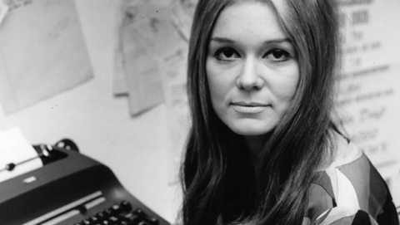
When Steinem returned from India she moved to Cambridge, MA and took a job as a journalist. She was asked to write about a rally organized by a feminist group called the Redstockings. Steinem was only there to report on the rally, but she joined their movement after hearing the women there talk about their challenges as women. She realized their stories were similar to her own. Steinem wanted to help the many women who were not being seen with the potential that men are seen with. Since then, she has become one of the most recognized modern feminists.
Joining the feminist movement had positive and negative consequences for Steinem. The National Organization for Women (NOW) said she was too extreme. The Redstockings said she wasn’t extreme enough. This couldn’t stop Steinem. She has always believed that women shouldn’t accept things the way they are, but they should organize together to give all women more opportunities. In 1972 she created the Ms. Magazine for women who thought the way she did. Ms. Magazine covered politics and women’s rights, unlike any other magazine for women at the time. That same year, Steinem represented the National Women’s Political Caucus, an organization that worked to help women get elected into political office. She has helped many organizations, including the Women’s Media Center and the Ms. Foundation for Women. Her work has influenced many of other feminists to speak up and join together.
She has had many chances to stand down and to give up, but nevertheless, she persisted.
I admire Gloria Steinem for her work in women’s rights. For the past forty-eight years, she has been trying to get women involved in controlling their lives and the country they live in. Steinem has been trying to give women the voice and authority they are entitled to, and she is succeeding. She is not finished, as there is a lot more to be done for equality. She has had many chances to stand down and to give up, but nevertheless, she persisted. Gloria Steinem's life has demonstrated to me that the place of women in society is not permanent and can be changed, and I can change it.

Michaela Edwards – Mary Jackson

Mary Jackson
If I had to pick a historical figure that I looked up to, they would have some of the following traits. They would be brave, fight for what they believed, they would push through anything they had to, and they would never take no for an answer. Someone that I thought fit this description was Mary Jackson. Having to fight through segregation and gender inequality for something that seemed impossible, Jackson blew everyone away when she succeeded. Jackson was born on April 9th, 1921, to Ella and Frank Jackson. Jackson was raised in Hampton, Virginia, where she found her love of math and science in school. But let me just say, this journey wasn’t easy!
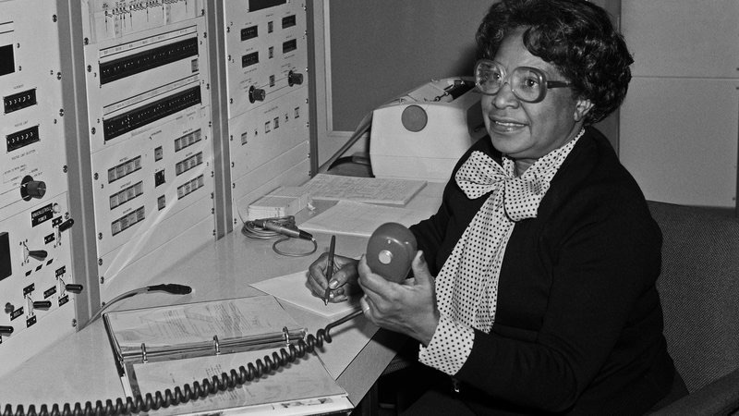
Even as a child Jackson had a knack for math and science. Each year in school Jackson graduated with the highest grades. In 1942 Jackson graduated from an all -black college called Hampton Institute. She graduated with bachelors’ degrees in both mathematics and physical science. A year later she accepted a job as a teacher for an all- black school in Maryland. She decided it was her responsibility to give those other black children a chance for good education. Jackson knew that lots of black children didn’t know it was even possible to become scientists or mathematicians because they were black. After a few years of teaching she decided to go back home and find a new job. It turned out, because it was the peak of segregation, it was harder than before to find employment. She got a few offers as a book keeper at various colleges, a librarian, and other jobs that didn’t really mean anything to her. It wasn’t long until she landed a spot at NASA’s segregated female computing section in 1951. At the time it was the only available job for black women. Though Jackson was bored and knew she could do more, it was a critical turning point in her career. Jackson was one of the smartest and hardest working in the program.
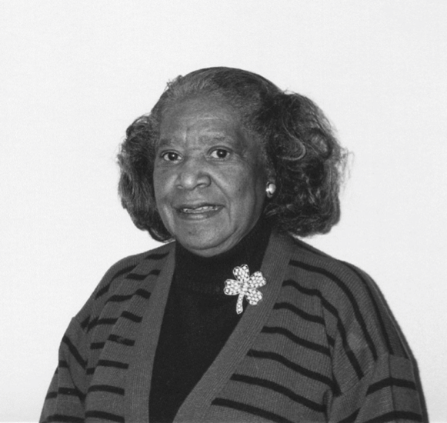
After two years of working there, Jackson got a chance to work with a NASA engineer. More than anything, Jackson wanted a spot in the engineering department. The engineer’s name was Kazimierz Czarnecki. Having spent just a few days with Jackson, Czarnecki knew he had to try to convince her to join a class and become an engineer. Jackson right away came up with several reasons that it wouldn’t work. She knew that very few people would accept her, the classes were at an all -white school, and there were no job openings for female engineers at NASA. When Czarnecki asked Jackson if she would attempt to be an engineer had she been born white and male, she responded, “I wouldn’t have to because I’d already be one.” At this he told her that she had to at least try. Jackson went to the school and asked to sign up for the classes. The principal just laughed and waved her off. Everyone Jackson talked to, quickly denied her. Finally she went to court and fought for her right. Jackson explained that she was smarter than many of the current engineers, and that black women were just as good as white men. After much debate Jackson won her case. At the class she was avoided and ignored, even by the teacher. No one included Jackson in class discussions, and she always had to work alone. Never the less, Jackson graduated once again with top marks, and received an offer from NASA. In 1958 Jackson became the first black and female engineer at NASA.
Jackson was one of the smartest and most helpful people in the engineering department. She worked in and contributed to most of the branches of engineering at NASA. After 34 years at NASA Jackson had earned the senior most title in engineering. She went on to author and co-author twelve books for NASA and NACA. Jackson realized that she couldn’t get any further promotions without becoming a supervisor. She decided to take a job to serve in the Equal Opportunity Specialist field at NASA. In this job Jackson was able to give other blacks and females an equal opportunity to be what they wanted. Jackson helped bring out the next generation of female and black engineers, scientists, and mathematicians.
She later became the first black, and the first female engineer at NASA.

Jackson has an amazing, inspiring story. Her story makes people want to go after their dreams no matter the circumstances. Jackson has been a huge influence on many engineers and scientists in the past as well as today. NASA probably wouldn’t be where they are today without her. Because of her strength, resilience, and perseverance, Mary Jackson inspires me.

Aydin Hodjat – Serena Williams
Serena Williams

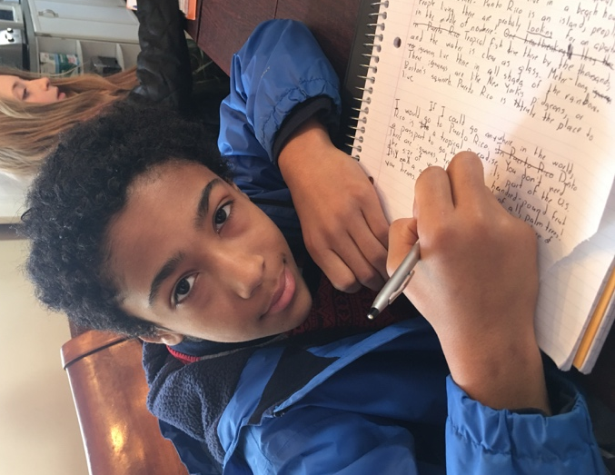
All people who play sports (including myself) have experiences similar to these: one loses a wrestling competition after the opponent dominates the final match. Or, the opposing soccer team scores a goal that could have easily been blocked, resulting in a lost game. Or, in a basketball game, a team is up by one in the final seconds of the game, and the other team’s point guard makes a monster dunk for the win. Everybody loses, and we all want to get better after losing. We all want to be able to block that player’s dunk so hard his teeth rattle. We all want to block that goal and be a hero. One has to work hard, though, to get better. Serena Williams is one of those people who work hard. She has overcome obstacles that would make the strongest among us despair. She has bulldozed through racism and disbelievers. This is why Serena Williams is one of my biggest role models.
Serena Williams was born in Michigan as the youngest of five sisters. At age nine, she moved to Florida for a tennis camp that her father wanted her to attend. Here, William’s talents flourished, and she was soon the number one under-10 tennis player in Florida. However, when Serena turned ten, her father stopped taking her to tennis tournaments because of the racist insults white parents would make. In William’s ninth year at school, her father pulled her from the tennis camp as well and started coaching her at home. Williams never allowed these hardships to turn her away from the game. Her desire to improve at the sport she loved was too great to let anybody throw her off her game, an incredible feat. These attributes are part of what makes her a role model.
When Williams first turned professional at the age of fourteen, she was not the exceptional player she is today. She learned from her mistakes, though. She focused on what she had to do and soon got better. In 1999, she won her first Grand Slam title at 17, making her the second African-American to do so, after Althea Gibson in 1956. In 2003, she set another milestone after winning the Australian Open tournament, becoming the first African-American to ever win the competition. Her hardworking attitude and intestinal fortitude kept the accolades coming. Serena soon gained popularity around the world. People started to notice her competitive drive and started to talk about her success on the court, another sign that hard work pays off.
With every swing of her racquet, she smashes through walls and proves the disbelievers wrong.
William’s amazing accomplishments are not limited to the tennis court. The Serena Williams Foundation has helped over 10,000 underprivileged U.S. students get college scholarships. She uses her wealth to help those in need, another admirable trait. She is a generous and caring person. It is remarkable when a rich person uses their fortune to help solve issues around the world. Williams has missed days of training and nearly tournaments themselves to help with disasters around the world. We all strive to be good people. Those who do accomplish that goal and do it prolifically are the notable ones. Those who do it without a thought are the greats.
Serena Williams is an unbelievable person. She is an excellent tennis player and a hard worker. She is a kind person both on and off the court, and uses her money to help those in need. She has written books to help young and old tennis players alike. Williams is a great example and a leader. I wish someday to achieve even half of what she has done. She is a role model to us all.

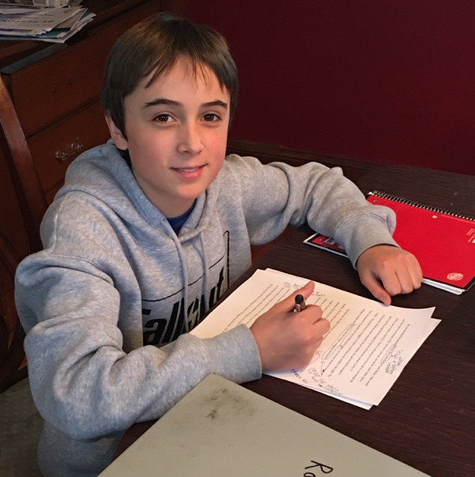
Romeo Pelletier – Bill Nye
Bill Nye: The Science Guy of Science
William Sanford “Bill” Nye is a scientist, TV producer and author. He is best known as “Bill Nye the Science Guy” from his educational TV show. Some scientific fields that he has studied are astronomy, physics and mechanical engineering. He is the CEO of The Planetary Society, a non-governmental, non-profit organization for research in engineering. He is also the author of many books on various scientific subjects. Bill Nye has studied a wide range of scientific fields and used theme to make science comprehensible to the public.
Nye studied mechanical engineering and went on to invent many useful things in that field. He studied at Cornell University, where he was taught by astronomer and author Carl Sagan. Nye earned a degree in mechanical engineering there. His first job was in Seattle at a plane and satellite manufacturer called Boeing. While he was there, he invented a hydraulic pressure resonance suppressor for the 747 plane. Afterwards, he worked as an aeronautics consultant. He later invented a sundial that was used as a color calibrator and clock on a Mars rover. Through his studies and inventions, he has made a great impact on the field of mechanical engineering.
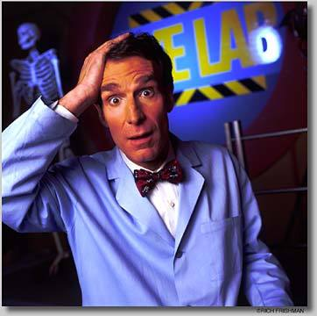
Not only did he contribute to mechanical engineering, he went on to be a science educator, comedian and author. His educational science/comedy show “Bill Nye the Science Guy” covered all subjects of science. The topics ranged from Earth science to planetary science to atomic science. The show aired from 1992-1998. It consisted of one hundred half-hour shows. He is also the author of many books. They have informed adults and children alike to all the different types of science out there. His shows and books have enlightened many people.
Bill Nye is certainly someone who inspires me. He works hard to expose climate change and he speaks out against creationism. Proof of this can be found in the countless “Save the Earth” style organizations he has started and his debate with creationist Ken Ham on February 4th, 2014. Another thing that I like about Nye is his previously mentioned TV show “Bill Nye the Science Guy.” When my dad was teaching my brother and I science, he used those shows as a fundamental teaching tool. Those shows exposed me to science very early on and made learning it fun. I also like him as an author. I listened to one of his books on tape, “Undeniable, Evolution and the Science of Creation”, and it was very interesting and informative. Bill Nye has influenced my scientific interests and ideas ever since I was very young.
Bill Nye is an amazing person who has made a huge educational impact on people of all ages. He invented many useful items that scientists are using now. He educated massive amounts of people about global warming, evolution and lots of other things. He has inspired countless people to learn more about science and question more. Bill Nye is truly an incredible person.
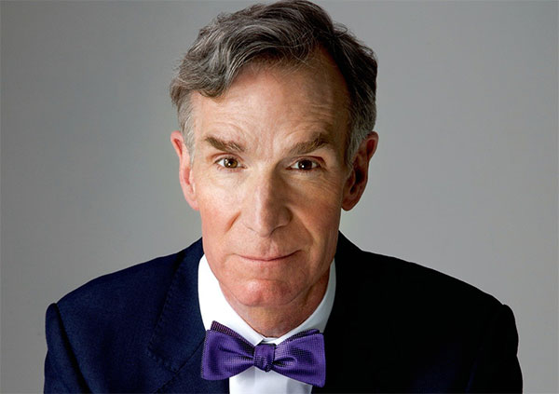
He later invented a sundial that was used as a color calibrator and clock on a Mars rover.

Colette Stamatos – Yusra Mardini

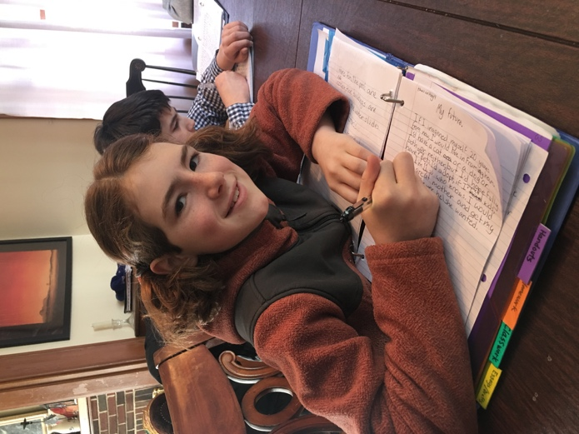
Yusra Mardini

Yusra Mardini is one of my favorite historical figures, but how I found out about her, I believe, is strange. One day my mother wrote the name Yusra Mardini on the wall in our kitchen. At the time, I had no idea who she was, but I asked, and found out! Yusra Mardini is a brave refugee from Syria. She swam in the 2016 Summer Olympics. She is now 18 years old and lives with her parents in Berlin, Germany. She fled from Syria because her house was bombed and there was a civil war. She is amazing to me because she swam for her life.
Mardini left Syria and first went to Turkey. She paid smugglers to take her on a boat to Lesbos, Greece. She was not alone. The boat, meant for only six people, was holding 20, including her one sister, Sarah. It was important to everyone to escape. Almost immediately, though, the boat motor broke under the weight of the people. Mardini was brave at this time, and even braver afterwards.
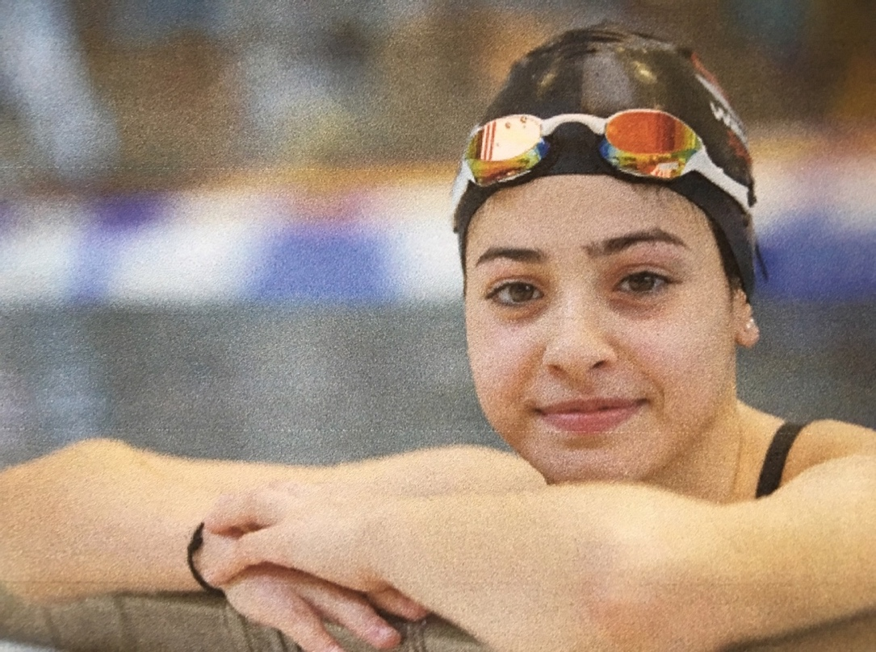
When the motor slowed, and then stopped completely, everyone started screaming in terror in fear of the boat sinking with them in it. Though help came, Mardini, her sister, and two men, were the only ones who could swim, and they jumped into the ice cold water. The men got tired of pushing the boat, but Mardini swam the whole way with Sarah. It was three long, stressful, tiring hours swimming across the sea. Her training for the Olympics definitely payed off. Mardini is a very courageous swimmer.

Mardini is also a very strong person in general. She was training for the Olympics in Syria before she left. The training center had been bombed, but everyone courageously continued training. They could see the sky through the ceiling, it was dangerous and horrifying, but they all were determined. Yusra Mardini saved lives by swimming, using the same courage she had at the training center. Mardini swam in the 2016 Summer Olympics on the first ever refugee team. She won her first heat in the 100 meter butterfly kick. Mardini’s story encourages me, though I hate it, to learn how to swim.
…everyone started screaming in terror in fear of the boat sinking with them in it.

This is all true information of a woman who fled her country in the Syrian civil war. She also saved lives, including her own, by swimming! She is an inspiring person because when times are hard she keeps going. One quote from Yusra Mardini is “life will not stop for you because you have pain. ” She now lives in Germany and is very happy there. This young individual is one of the greatest swimmers I have heard of.

